SauceDemo – Defect Report
This defect report is created based on SauceDemo Testing Documentation & Test Cases and the observed behavior in the provided screenshots. Each defect includes clear steps, expected vs actual results, and references the relevant screenshot as evidence.

Defect 1: Locked Out User Unable to Login (Negative Scenario – Expected Behavior)
Defect ID: SD-LOGIN-001
Module: Login
Test Case Reference: Login – Locked Out User
Severity: Low
Priority: Low
Status: Pass (Expected Defect)
Description:
When logging in with the username locked_out_user, the system displays an error message stating the user has been locked out.
Steps to Reproduce: 1. Navigate to SauceDemo login page 2. Enter username: locked_out_user 3. Enter password: secret_sauce 4. Click Login
Expected Result:
User should not be able to log in and an appropriate error message should be displayed.
Actual Result:
Error message displayed: “Epic sadface: Sorry, this user has been locked out.”
Evidence:
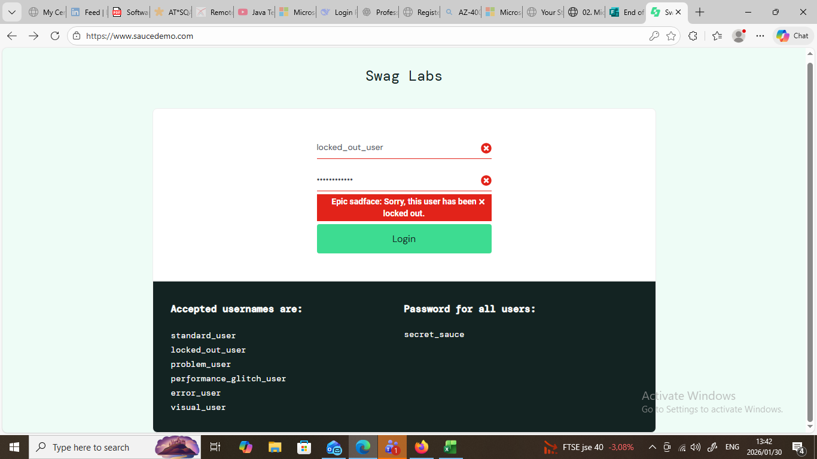

Defect 2: Checkout Allows Invalid Postal Code Format (Alphanumeric)
Defect ID: SD-CHECKOUT-002
Module: Checkout – Your Information
Test Case Reference: Checkout Validation – Postal Code
Severity: Medium
Priority: Medium
Status: Fail
Description:
The application allows checkout to proceed even when an invalid postal code containing alphabets is entered.
Steps to Reproduce: 1. Login with valid user credentials
2. Add any product to cart
3. Navigate to Checkout
4. Enter First Name and Last Name
5. Enter Postal Code as ABCDE
6. Click Continue
Expected Result:
System should display validation error and prevent navigation to overview page.
Actual Result:
User is allowed to proceed to Checkout Overview page.
Evidence:
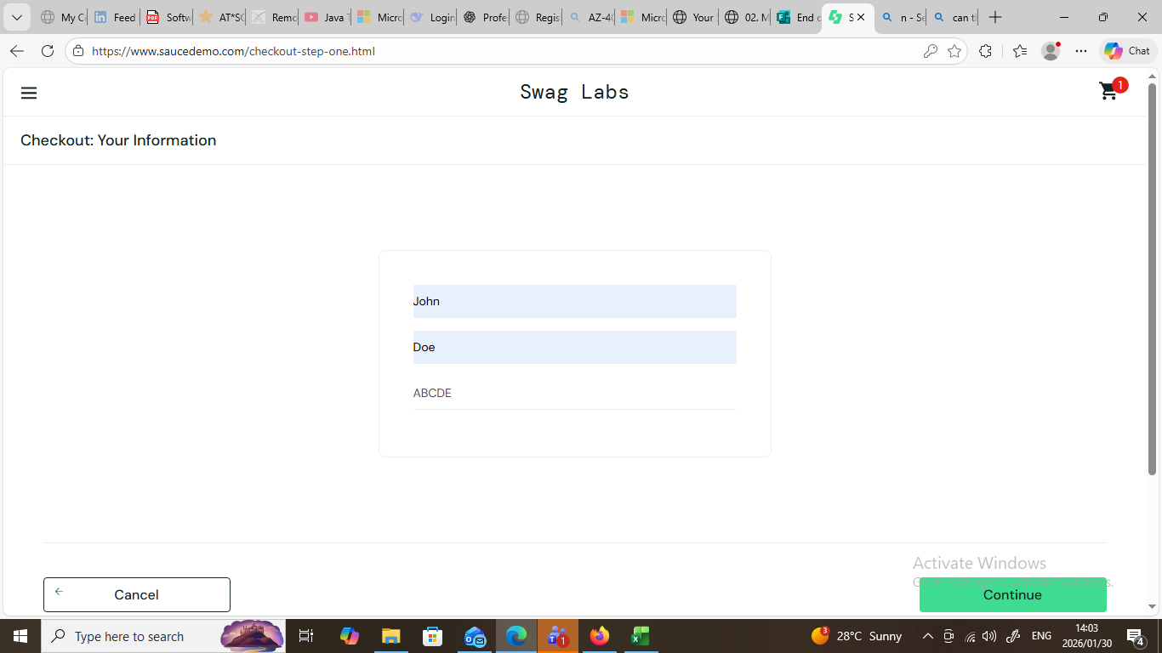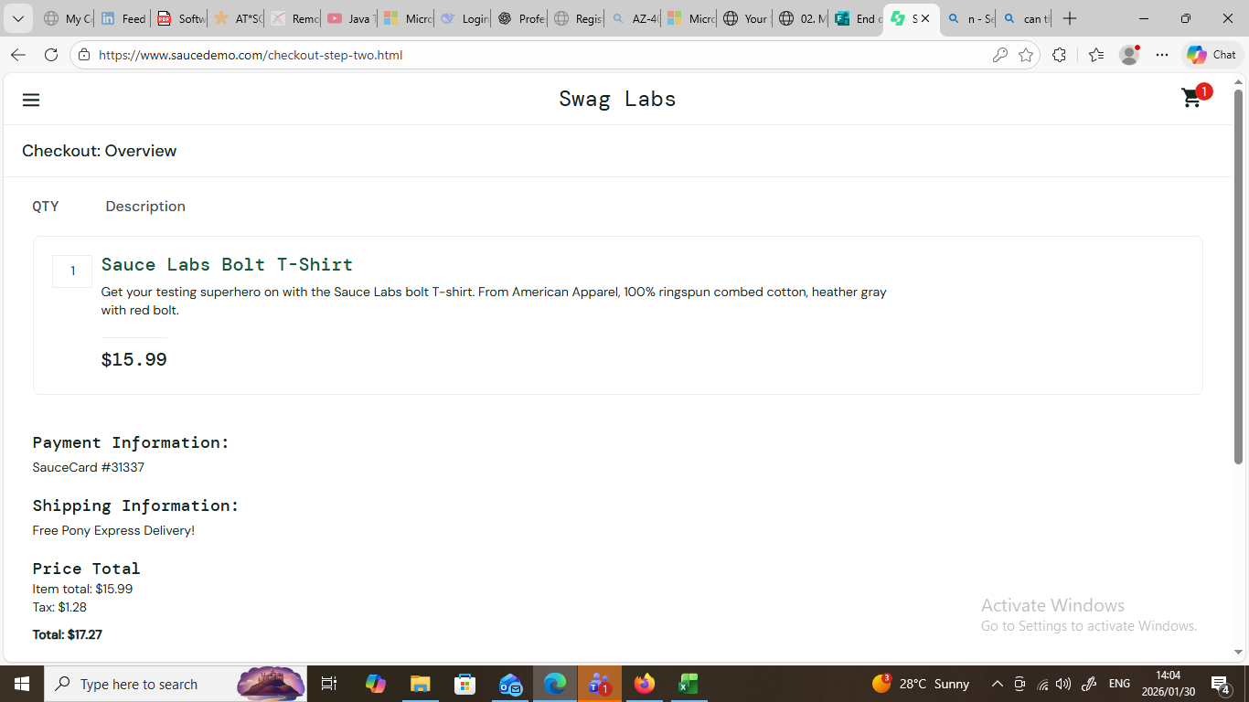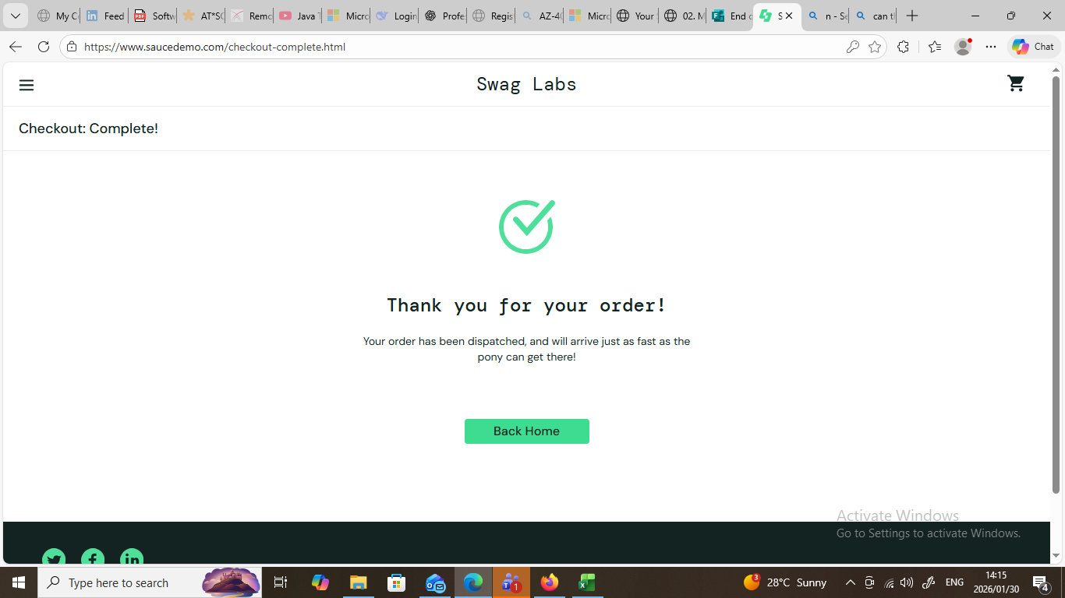

Defect 3: Checkout Allows Invalid Postal Code with Trailing Hyphen
Defect ID: SD-CHECKOUT-003
Module: Checkout – Your Information
Test Case Reference: Checkout Validation – Postal Code Format
Severity: Medium
Priority: Medium
Status: Fail
Description:
The system accepts a postal code with trailing special characters (e.g., 12345-).
Steps to Reproduce: 1. Login with standard user
2. Add product to cart
3. Proceed to Checkout
4. Enter First Name and Last Name
5. Enter Postal Code as 12345-
6. Click Continue
Expected Result:
System should validate postal code format and block continuation.
Actual Result:
User is successfully navigated to Checkout Overview.
Evidence:
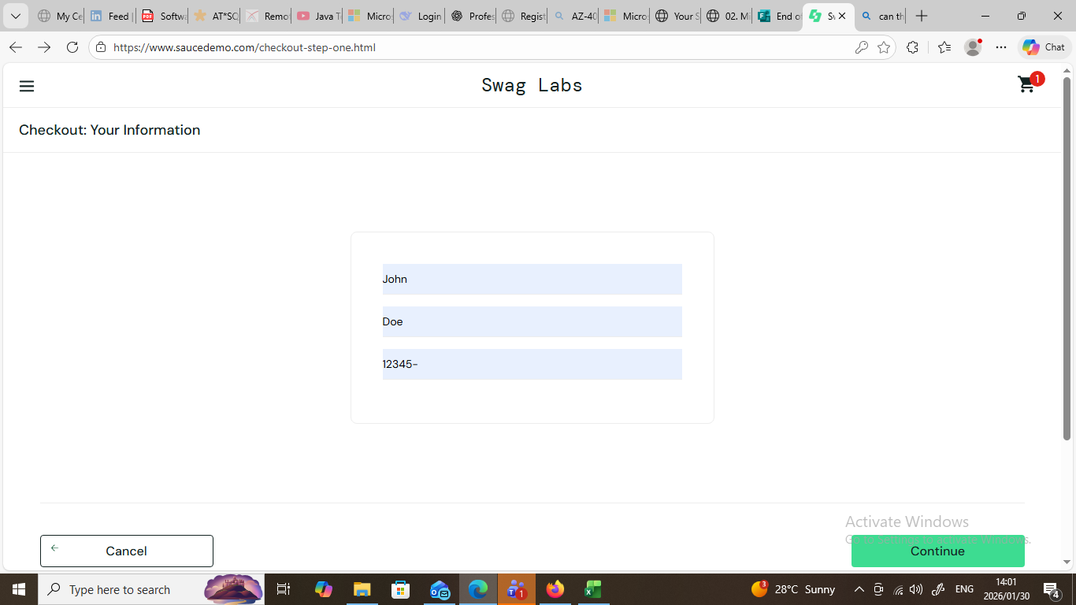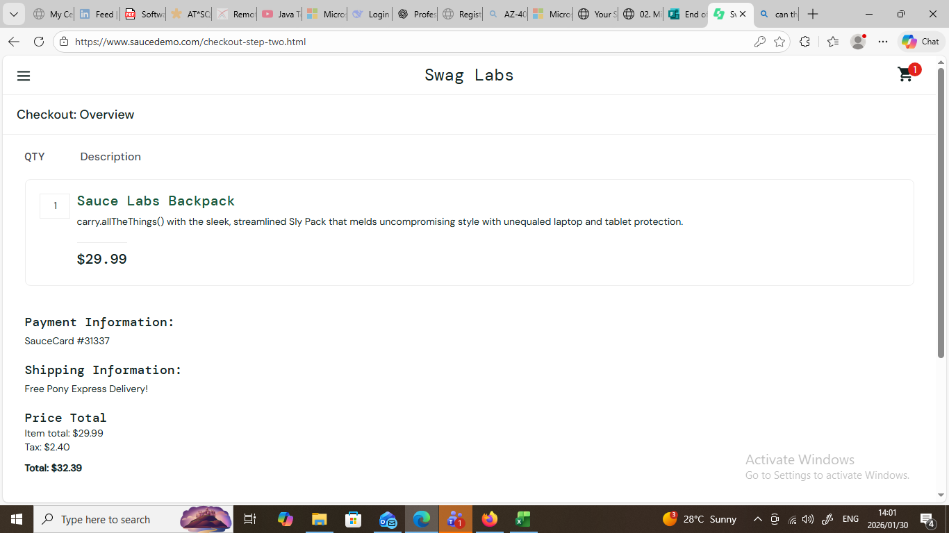

Defect 4: Finish Button Not Working for error_user During Checkout
Defect ID: SD-CHK-020
Module: Checkout
Test Case Reference: CHK_020
Severity: High
Priority: High
Status: Fail
Description:
When logged in as error_user, the Finish button on the Checkout (Step 2 – Overview) page does not function correctly, preventing the user from completing the checkout flow.
Preconditions:
- User is logged in as error_user
- At least one item is added to the cart
Steps to Reproduce:
- Login with username: error_user and password: secret_sauce
- Add any item to the cart
- Navigate to the Cart page
- Click Checkout
- Complete Checkout Step 1 with valid information
- On Checkout Step 2 (Overview), click Finish
Expected Result:
User should be redirected to the Checkout Complete page after clicking the Finish button.
Actual Result:
The Finish button does not work correctly.
The order is not completed as expected and the checkout flow does not behave consistently for error_user.
Impact / Business Risk
- User is unable to complete purchase
- Breaks end-to-end checkout flow
- Direct revenue impact
- Creates inconsistent behaviour between user roles
Evidence:
